Lab Exercise Create an AWS KMS Key and Encrypt an Amazon S3 Bucket Using AWS CloudShell

Objective

In this lab, you will learn how to:
- Create a Customer Managed KMS Key using AWS CLI.
- Create an Amazon S3 bucket.
- Enable default KMS encryption on the bucket.
- Upload files to the encrypted bucket.
- Verify that uploaded objects are encrypted using AWS KMS.
- Download encrypted objects.
- Disable and re-enable the KMS key to observe its effect.

Estimated Time

40–50 Minutes

Prerequisites
- AWS Account
- AWS CloudShell
- IAM permissions for:
  - AWS KMS
  - Amazon S3

Architecture

+------------------------+

| AWS KMS |

| Customer Managed Key |

+-----------+------------+

|

|

Encrypt / Decrypt

|

▼

+----------------------+

| Amazon S3 Bucket |

| kms-demo-bucket |

+----------+-----------+

|

Encrypted Objects

Part 1 – Open AWS CloudShell
- Login to the AWS Management Console.
- Open CloudShell.
- Wait until the terminal is ready.

Part 2 – Set Variables

REGION=us-east-1

BUCKET_NAME=kms-demo-bucket-$RANDOM

Verify

echo $BUCKET_NAME

Part 3 – Create a Customer Managed KMS Key

Create the key.

aws kms create-key \

--description "KMS Key for S3 Encryption"

Example Output

{

"KeyMetadata": {

"KeyId": "12345678-abcd-1234-abcd-1234567890ab",

"Arn": "arn:aws:kms:us-east-1:123456789012:key/12345678-abcd-1234-abcd-1234567890ab"

}

}

Save the Key ID

Replace with your own value.

KMS_KEY_ID=12345678-abcd-1234-abcd-1234567890ab

Verify

echo $KMS_KEY_ID

Part 4 – Create an Alias

aws kms create-alias \

--alias-name alias/lab-s3-key \

--target-key-id $KMS_KEY_ID

Verify

aws kms list-aliases

Expected Output

Alias

alias/lab-s3-key

should appear.

Part 5 – Create an S3 Bucket

aws s3api create-bucket \

--bucket $BUCKET_NAME \

--region $REGION

Verify

aws s3 ls

Part 6 – Enable KMS Encryption on the Bucket

aws s3api put-bucket-encryption \

--bucket $BUCKET_NAME \

--server-side-encryption-configuration '{

"Rules":[

{

"ApplyServerSideEncryptionByDefault":{

"SSEAlgorithm":"aws:kms",

"KMSMasterKeyID":"alias/lab-s3-key"

}

}

]

}'

Verify

aws s3api get-bucket-encryption \

--bucket $BUCKET_NAME

Expected Output

aws:kms

Part 7 – Create Sample Files

echo "AWS KMS Lab File 1" > report1.txt

echo "AWS KMS Lab File 2" > report2.txt

Verify

ls

Part 8 – Upload Files

aws s3 cp report1.txt s3://$BUCKET_NAME/

aws s3 cp report2.txt s3://$BUCKET_NAME/

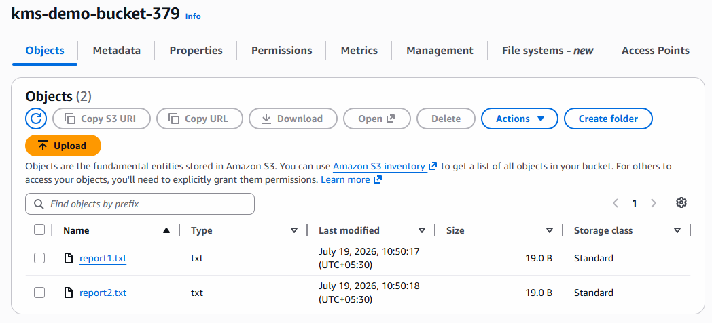

Verify

aws s3 ls s3://$BUCKET_NAME

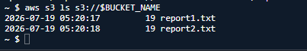

Expected Output

report1.txt

report2.txt

Part 9 – Verify Object Encryption

aws s3api head-object \

--bucket $BUCKET_NAME \

--key report1.txt

Expected Output

"ServerSideEncryption": "aws:kms"

and

"SSEKMSKeyId"

Part 10 – Download the File

aws s3 cp \

s3://$BUCKET_NAME/report1.txt .

Display contents

cat report1.txt

Expected Output

AWS KMS Lab File 1

Part 11 – Disable the KMS Key

aws kms disable-key \

--key-id $KMS_KEY_ID

Verify

aws kms describe-key \

--key-id $KMS_KEY_ID

Expected Output

Enabled: false

Part 12 – Test Access

Try downloading again.

aws s3 cp \

s3://$BUCKET_NAME/report2.txt .

Expected Output

Access fails because the KMS key is disabled.

Part 13 – Enable the Key Again

aws kms enable-key \

--key-id $KMS_KEY_ID

Download again.

aws s3 cp \

s3://$BUCKET_NAME/report2.txt .

Display

cat report2.txt

Expected Output

AWS KMS Lab File 2

Part 14 – List Keys

aws kms list-keys

Part 15 – List Aliases

aws kms list-aliases

Part 16 – Clean Up

Delete the uploaded objects.

aws s3 rm s3://$BUCKET_NAME/report1.txt

aws s3 rm s3://$BUCKET_NAME/report2.txt

Delete the bucket.

aws s3 rb s3://$BUCKET_NAME

Schedule deletion of the KMS key (minimum waiting period is 7 days).

aws kms schedule-key-deletion \

--key-id $KMS_KEY_ID \

--pending-window-in-days 7

Expected Outcome

After completing this lab, you should be able to:
- Create a Customer Managed AWS KMS key using the AWS CLI.
- Create an Amazon S3 bucket from AWS CloudShell.
- Configure default server-side encryption using AWS KMS.
- Upload and download encrypted objects.
- Verify that S3 objects are encrypted with AWS KMS.
- Understand the impact of disabling a KMS key on encrypted data access.
- Clean up AWS resources created during the lab.

